Goddess Threshold, by Peter someone, @ 2009
Threshold Goddess

Seek me between the sparking
and the flaring of the flame
Between the recognition,
and remembering of the name.
Seek me between the seafoam
and the golden stretch of sand
I balance ‘tixt conception
and the rendering of the plan.

Between the icy midnight
and the noontide’s weltering heat,
Between the throbbing drumhead
and the next impending beat,
Between the in-drawn breath,
and the singing of the words
Between the smithy’s hammer
and the ringing clash of swords.

You’ll find me ‘twixt the glitter,
and the falling of the tear,
When the ghost of songs forgotten
sends nostalgia winging near.
Between the fevered dreaming
and fulfillment of desire,
Between the in and out,
where the threshold’s limned with fire.

I speak between the cadence,
and my footprint fills with gold
My voice fills up the hollow
of the truth that’s never told:
That I wait between the caring,
and the lending of your hand,
For with all of where you’ll find me,
there alone, you’ll understand.

Invocation to Brighid

In the pulse of the hammer, and tongue of the flame,
The steel in the speaking of bold, ancient names.
In the magic of making for tearing apart,
Is the song, and the sword, and the name of the art.

That She makes for the making of that ‘neath Her hand,
That She tests for the temper, the world to withstand,
That each blade is a baby, each song is a son,
And the sharing of either, a war fought and won.
Oh stand, place your foot on the edge of the stage
Face to the forge, and give voice to the blaze
Your heart wields the hammer, the anvil; your soul
Stretch your hand to the magic, and bring it in full

That the song may speak savage when wielded with skill,
That the blade keeps its beauty when freed of the kill,
That the war of the poet is fought with the page,
And the songs of the soldiers live, thoughtless of age.
Oh come, raise your sword, and your hammer, and pen
Rise to Her call and do magic again
Strive as though never you thought to retire
For the Covenant’s sealed when the listeners take fire

In the hand of the drummer that marshals the beat,
The silver strings blazing with un-dimming heat
In the passion and power and pride of the world,
In this Goddess in Glory in Genius unfurled.

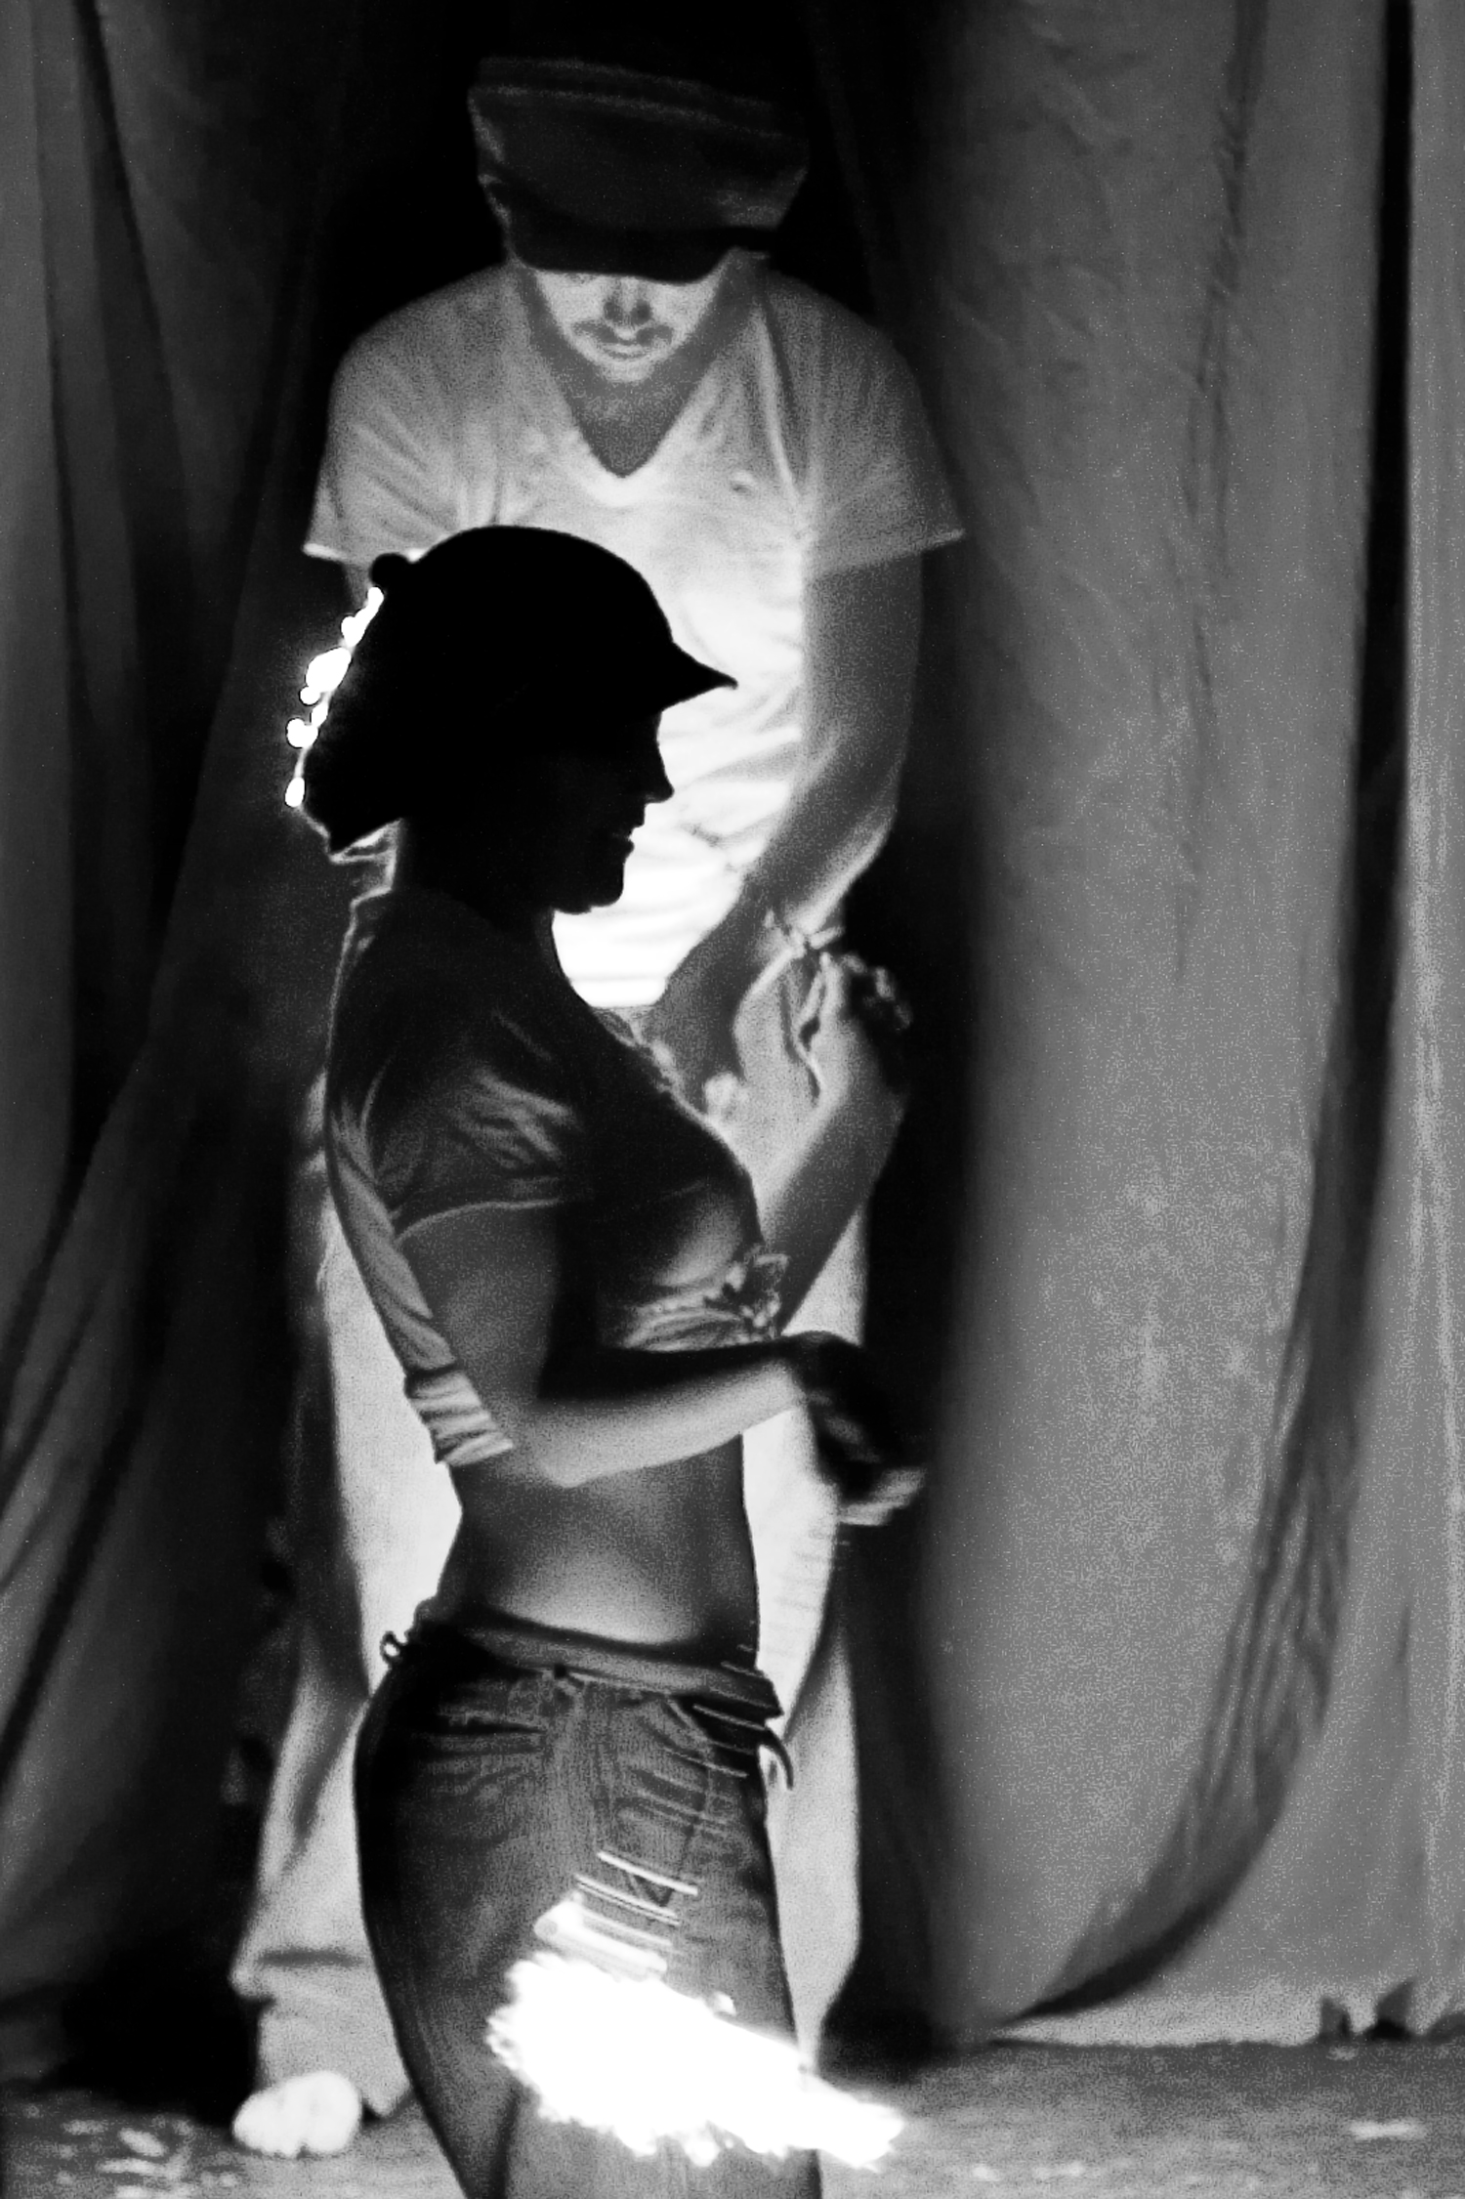

Fire Flow by Ken Kingsgrave-Ernstein @ 2006

A Spell to Make a Woman

Hair of honeyed Meadowsweet,
Bloom of Rose upon the cheek,
Violet's depth to weigh the eyes
As blue as any summer skies,
Lilies for the span of breast,
And Lotus rare to sweet the breath.
Bone be hewn of white Ash wood,
And Poppies red to fire the blood,
The Willow's grace her form to light,
And Orchid lips to bloom at night,
Proud Iris in the lift of head,
And let her name be Blodduedd.

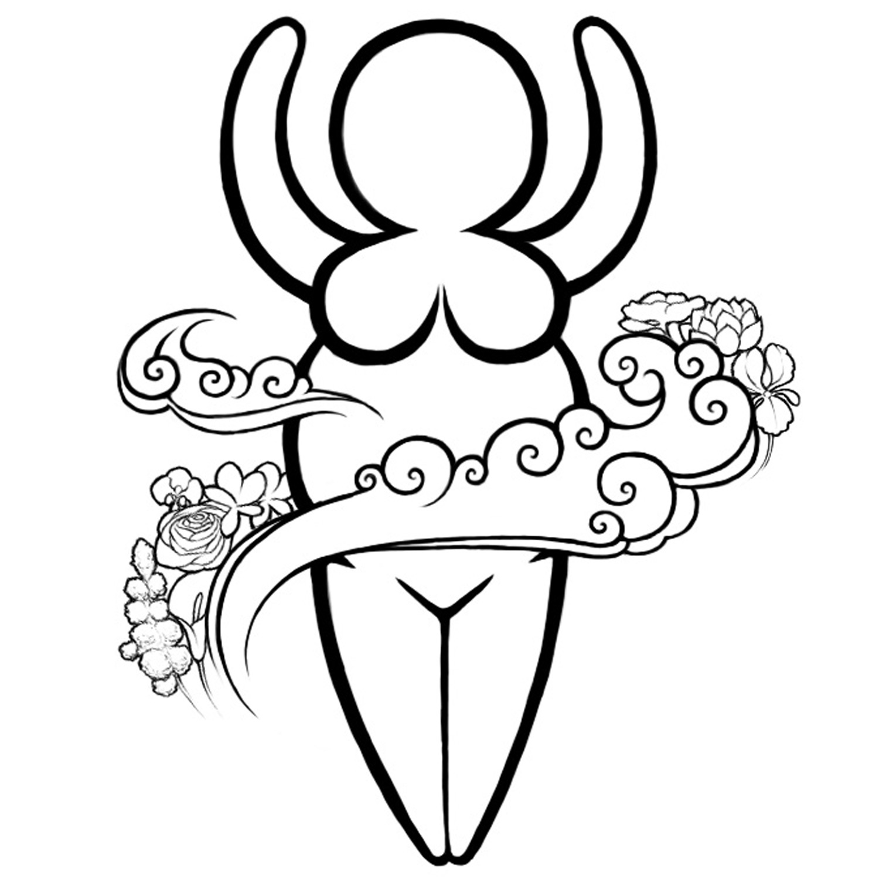

A Spell to Make a Woman by Sarah D Williss @ 2009

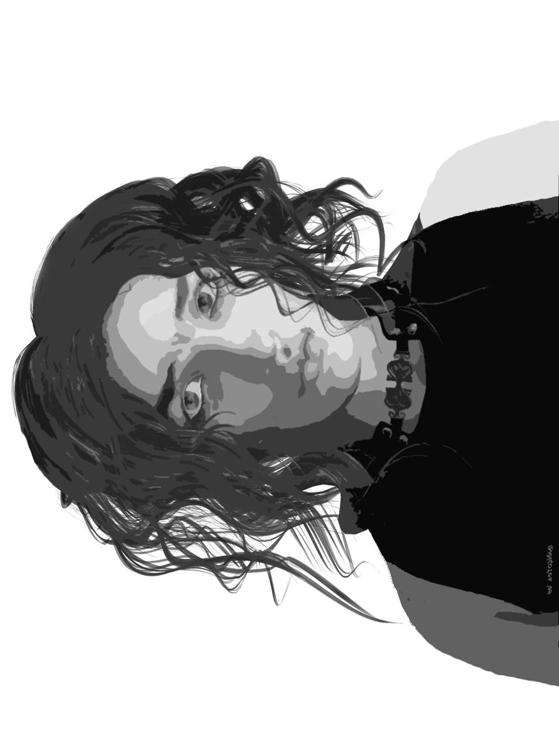

Ravenwing by Carole Bennett @ 2009
Battle Raven

I am one sword out of many, I am one face out of three
The Maiden, Crone, and Mother live united within me
For I am woman's fury, and her honour and her pain
And before this day is over, oh, the blood shall fall like rain!

Bring me thunder, bring me steel, bring me coat of iron mail
Bring me diamond hardened will and let my courage never fail.
Bring the Lightning to my sword; lashing, living in my hand
And bring warning to the horde that here,
the Battle Raven stands.

I am wind and rain and fire, I am venom, blood, and tears.
I can raise a fury higher than the worst of mortal fears
I am woman for the women and the children and the home
I will raise my cry in battle with an army -- or alone!

When the Raven stands to battle, I will heed no pleading word
I will grant no foeman quarter; fallen men raise not the sword.
For I know no rules of warring; this is not some bloody game
This is kill, or die in trying, 'cause your foe will do the same!

I will sing to bring the thunder crashing down from out the sky
And I'll sing to light the souls of all the warriors soon to die
And I will sing in battle, bloody songs of power and pain
And I will sing tonight for War to never come again.

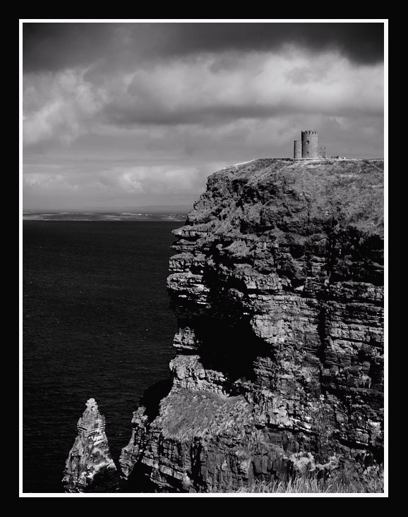

O’Brien’s Tower – Cliffs of Moher by Neevel @ 2006
An Ode to My Amazon

I would take up the sun, and bear it shining to your heart,
I would dry up the lingering damp that haunts your velvet eye,
I would card out your fears to give your hopes a leaping start,
But you would only look at me, and shake your head and sigh
Because I never learn that you are too fierce to protect,
And that your many wounds are all that make you feel alive
And that your life points forward, with small room for regret,
And less room for the ones who want to keep you from the dive.
And so, to mark your Day, I offer cliffs of daring height
And gales beneath to bear aloft your hunting-raptor wings.
I bless your flashing eye, and bid it put your foes to flight
And in the lull of battle, I will bring you softer things:
A pillow of my breath for when you can't hold up your head,
My Sight, for when your own's occluded by surrounding trees,
My shadow right behind you when your fears won't let you sleep,
And all the hope I have when all your own hope simply flees.
I am to you no better than a friend;
The best I hope to be, though, in the end.

Box Five Lament

You’re falling in love – I can hear when you’re speaking.
You’re falling in love – I can see in your eye.
You’re thinking of her when you cannot be with her,
And what right have I to be wanting to die?

How dare I say this is killing me?
How dare I tell you I hate the whole thing?
You never were mine, so then how can I lose you?
My heart has me screaming, how am I to sing?

If you knew, you would tell me that nothing is changing
You’d hold me and say that we two are the same.
But this opera’s due for a change in the staging:
The new Prima Donna deserves all the fame.

How can I feel it’s not over?
All I can see is I’ve lost my last chance.
You don’t want to leave, so I can’t try and stop you.
My soul has me weeping, how am I to dance?

My sweet, you are no kind of liar.
Don’t think I’m afraid of deception from you
But we both know you’re feeling a fire
That can’t come from me, or the things I can do.
So pardon that I am pretending
That tears aren’t haunting each word that I say.
I never was good writing endings,
And I can’t bring myself to just push you away.

So you’re filled with romance, and I know that you need it.
The joy that she brings you shines bright in your eyes.
Your soul has been trapped, and her loving has freed it;
And I will not taint your new love with goodbyes.

I must learn to watch from the audience.
To cheer and applaud from the wings of the play.
I’ve spoken the lines, and I’ve trodden the measures;
I’ve loved you, I’ve lost you. No more’s left to say.

Sorceresses

We are witches, to a woman,
From the shadows of our womb
And we understand the birthing
As we understand the tomb
Though we know the rites of Moonlight
We do not fear the Sun,
And we are Sorceresses, every one.

By the blood that flows within us
At the turning of the Moon
We divine the rules of chaos
And we learn to sing its tune.
We’ve the stormy Sky for lover
And tomorrow for a son,
And we are Sorceresses, every one.

For the magic
Beats
Within each woman’s heart
And though many learn to hide it,
All have heard it from the start
And the force
Of change
Lies ready in our hands
We weave the living web
That holds forever in its strands

We know magic in our marrow,
Every woman, every girl,
Though we’ve learned to keep our wisdom
Close around us, tightly furled
And through centuries of secrecy,
Our work has gotten done;
That makes us Sorceresses,
Capricious Fate’s mistresses,

That makes us Sorceresses,
Every one.

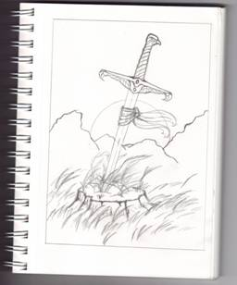

Remembering Hawk by Anne Campbell @ 2009
Hawk’s Memorare

I heard about you today, first time in years.
It took me most of the night to get around to feeling tears.
They didn’t fall: just hung there blurring everything together.
Black, white, wrong, right, depth, height, day, night...

Good God man, don’t you remember
when we meant to save the world?
How we’d laugh in the face of the foulest night
and live to see dawn unfurled?
You were a hawk of the morning, a knight of the sun,
A savior, a searcher, and one of my dearest friends...my only friends.
And when the last chord ends, who will remember?

You know you skived off without leaving me a picture?
I’ve nothing to show them, to point to, to tell them “that’s him.”
But then I guess it wouldn’t matter if I did.
'Cause a picture from then would be a lie,
And a picture from now would have ice in your eyes
Or blood.
Or something else I never wanted to see there.
Are you finally free there wherever you are?

Good God man, I can remember when
right and wrong meant more than life:
It didn’t matter the pain or the loss or the gain
for the motive was worth the strife
We were blades of the righteous, the promise of dawn
Crusaders, avengers, and children with armor on.

But now you’re gone.
And when the song plays on, who will remember?
Remember
Us, you, and what we wanted to prove,
And the reasons we fought, and the reasons we strove
And the lengths we would go to see justice was done
And the love and the lies and the battles we won
And the battle you lost.

I will remember, my friend.
I hope that can be enough.
It’s all I can do now.
But Hawk brother, I will remember you now.

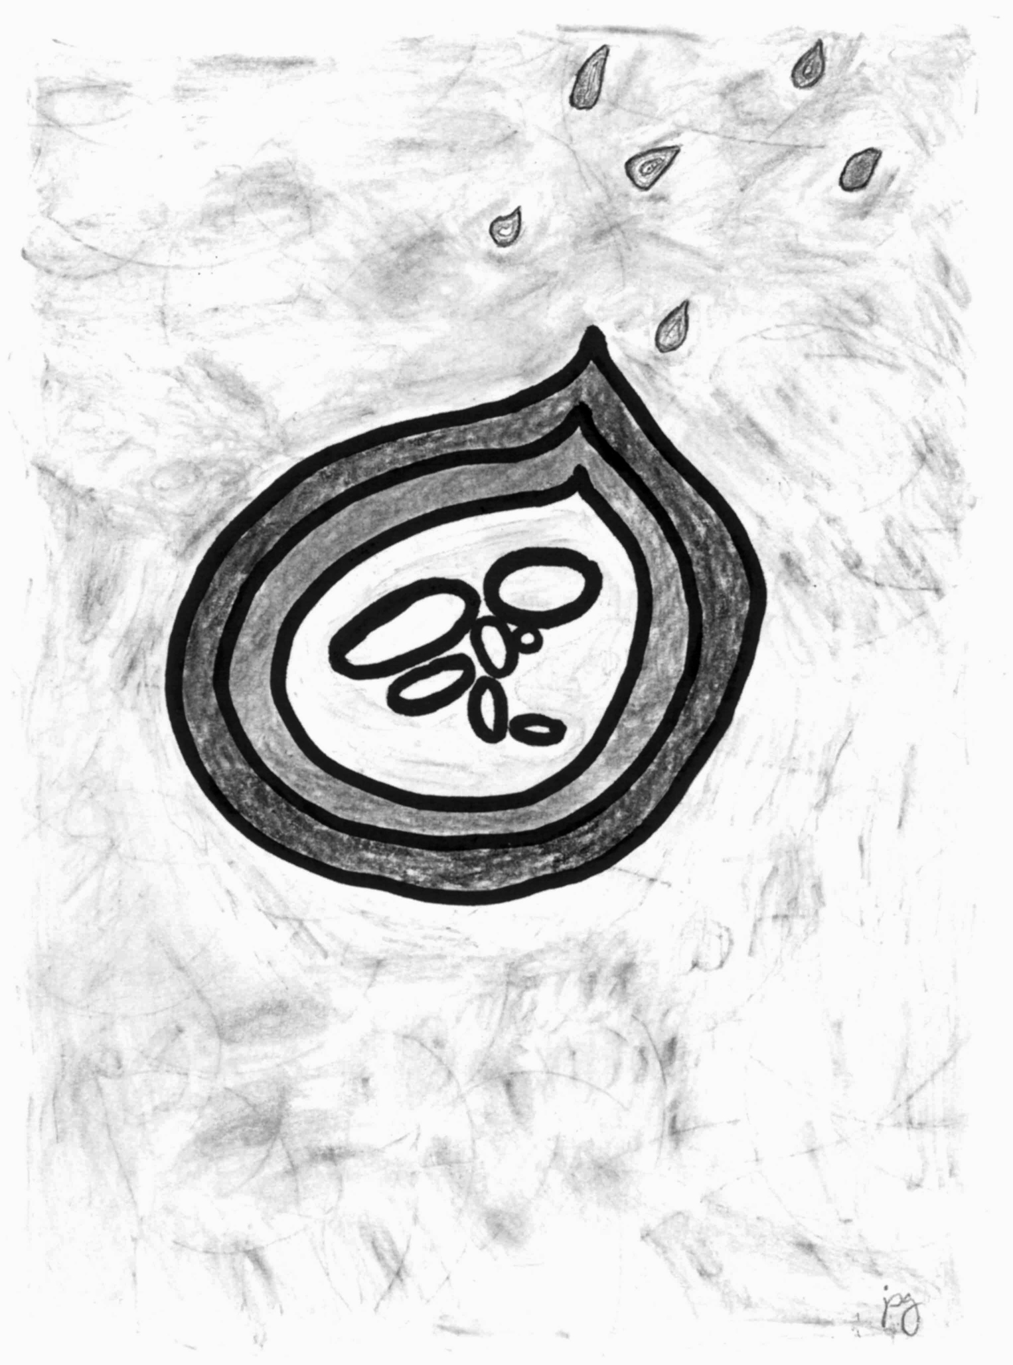

Fia by JPG @ 2009
Rainsong

The earth is fallow, hard and dry
Hammered flat ‘neath a merciless sky
No rain has fallen since the spring
And scant the life in any green thing
No pity walks abroad at noon
So we stand forth beneath the moon
And raise our voices in refrain
To heal this drought — to bring us rain

No water runs above the ground
The birds and beasts in ashes drown
Our deepest well’s most precious fruit
We sacrifice to this pursuit
That water may with heaven plead
An emissary to our need
And breaking summer’s dusty chain,
Beseech the sky to bring us rain.

We offer dust of barren fields,
Too dry beneath the plow to yield
We bring you crops we have cut down
When vernal green baked into brown
We bring you beasts that have no graze
Beneath Solaris’s fearsome gaze
We bring you ruin, prayers and pain
Receive them all, and bring us rain

Mount, ye waters, to the skies!
Bid the sudden storm arise!
Bid the pitchy clouds advance!
Bid the forked lightning’s glance!
Bid the angry thunder’s growl,
And bid the wild wind fiercely howl!
Bid the tempest come amain!
Thunder, Lightning, Wind and Rain!

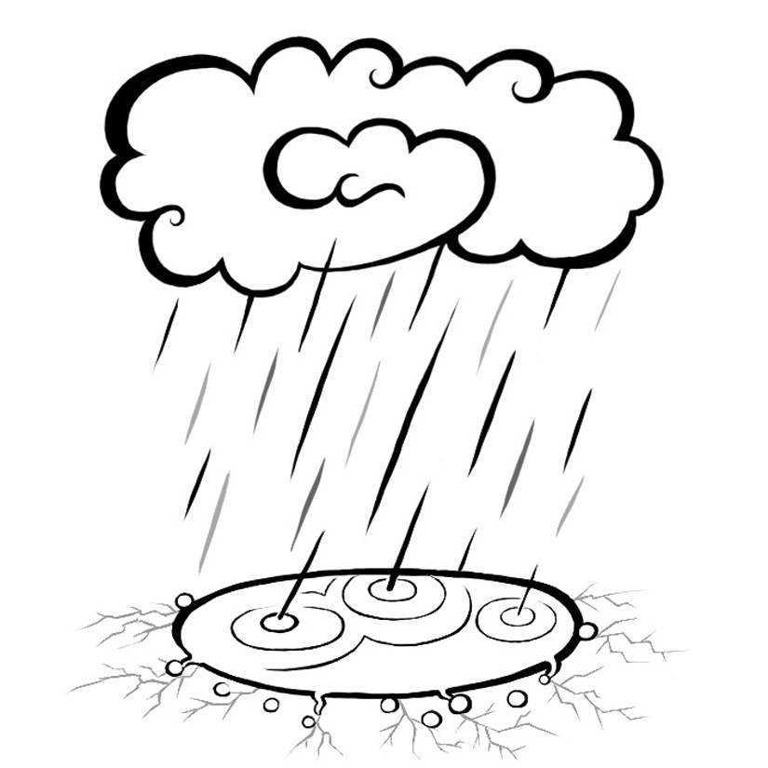

Rainsong by Sarah D Willis @2009
Heritage

My bones are carved out of the high Cymric mountains,
My blood is boiled up from the wild western sea.
The curve of the land’s in the length and the lie of me,
Oceans away, in another country.

The past is a Trickster that knows where it’s going,
The future a Bungler, no clue where it’s been,
And we live our lives in a handful of hours,
A Rogue being more or less same as a Queen.
And like threads in a tapestry each one is woven
Spun, measured and severed: to each his own span.
But each thread is spun from the threads cut before him;
A thousand caught up in the weft of a man.

There is a place where my feet have not trodden,
There is a language not known to my ears;
A passage of history my mind cannot fathom
And I never knew, but lives still with me here
In the pulse of a heart that in some way remembers
The touch of that earth, and the song of that sea.
In the loving passed down from the souls that have loved her
Till borne in my blood, it sings up out of me.

Her stories, they know me, her legends ring true
And I do not speak them, but let them speak through
To honour my heartland, across that wild sea
That I was formed of, and is rooted in me.

Someday I’ll go, if the Fates will prove kindly;
Set foot on Her earth, and my hand to her stones,
And She that was maker to all of my people
Shall open her arms, and shall welcome me home
And my bones will remember those high Cymric mountains,
My blood, it will pound with the crash of that sea.
The love of a people shall sing through the ages,
And all of those ages will sing out of me
Oceans away, in my Mother Country.

A Gift on Summer Solstice Night

The Goddess gave, as gift to me,
A field of stars this evening
When twilight soaked the air
With silk and indigo perfume
When, from out the grassy verge,
The spheres of heaven came winking
I paused, dumbfounded in my stride
To listen for the tune.
The bright pavanne wove at my knees,
No higher than my shoulder
As though the stretch of heaven's reach
Spread out before my hand
And I, slight mortal, caught my breath
To witness something older
Than any word that's spoke or heard
By any tongue of man.
This shroud of stars in rustling space,
This brilliant clutch of moments,
That light, upon the rising only,
Venerate and brief
Theirs is no future, no tomorrow,
Only lingering solstice
And death, with morning coming,
Is for them, no source of grief.
Let me from this take lesson,
On this pivot of the year
Oh give me faith to focus
On the road before the bend!
Let moments rise like fireflies,
And treasure what is here
And leave tomorrow's bounty,
Or tomorrow's death till then

Beltane Alone

My ribband is woven in;
Year upon year is plaited over it by hands my own have touched,
And never touched.
The maypole grows thicker by a layer of family
Each first of May that passes,
And it is a comfort to imagine the feel of them,
Strangers in face, family in name,
Twining over me and mine of older years.
But there is no plait in my hand today but my own tresses,
And these, I bind up tight against paint and cleanser and the fight
to stave off entropy and dust.
Today there is no fire leaping in my circle,
No leaping kisses o'er the flames,
No wishing cup,
no sunwise dance,
no flower crown,
And Crabapples, not Hawthorns, bloom.
And all within me is the feeling of waiting.
As though Beltane is for others now, and from me
the world wants only patience.
(I am not patient. Tolerant, perhaps, but not patient.)
It seems Samhain stays with me this year, dusting sage and sour-leaf smoulder through blossom's perfume,
Crunching sodden last-years underfoot where others tread
tender new green.
And yet I am not jealous.
Only outside it somehow.
Adrift along the wheel,
Carried by a tide I neither fight, nor understand,
But still aware;
That somewhere a family circles around my thread,
That somewhere wishes and kisses are traded
along a circle that knows my name
That somewhere, haws blossom white,
Sweet wine and sweeter bread is shared from hand to hand,
And Beltane's lush indulgence makes friends forget the winter.

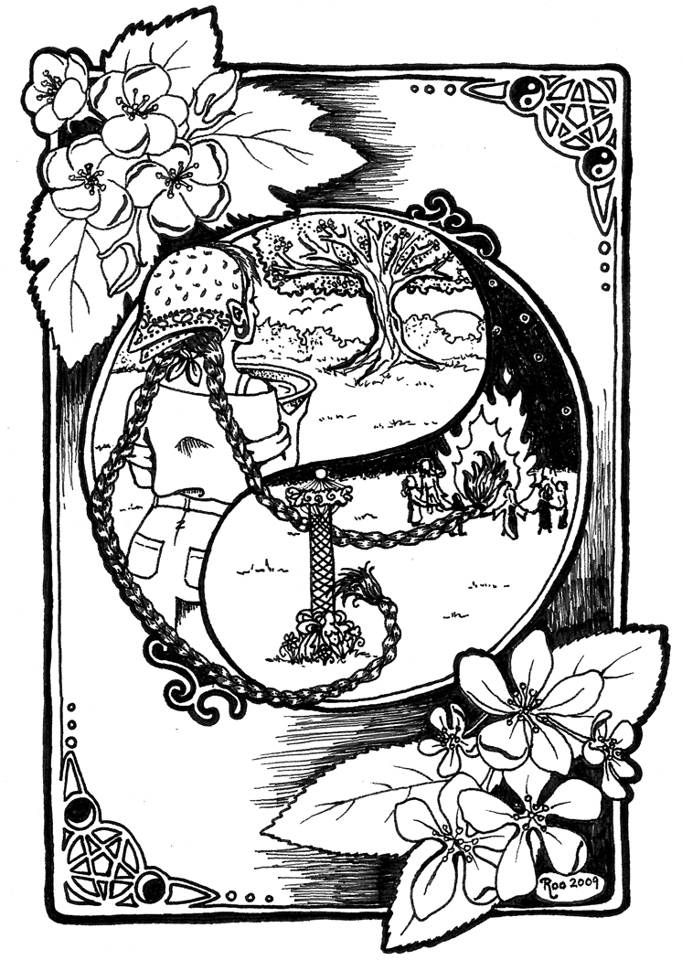

Beltane Alone by Roo @ 2009
I seek outside this grey and grisly morning, blue bowl dry in hand,
Three Orisha, Aphrodite, and Aeternia
salt-crusted to the bottom,
in company with
A single copper penny.
I am hunting rainwater in the grass.
Diamonds speckle the leaves and blades;
Beautiful, but too fragile to collect.
Hazard-dropped catches,
(Lids, empty flowerpots, pet bowls, wheelbarrows)
Too muddied, too cluttered with wind-debris to suit.
At last, irony yields the answer;
Plastic, obsolete and unnatural as any chimera,
forms a perfect azure pool
Grist and sodden petals lurk at the bottom,
But in between,
The medium is clear as air and numbingly cold.
A drizzle first to loosen the salty days dried up within,
Left hand stirring widdershins until
The midnight bowl is milky and rattling
Then out it pours across the threshold,
The Ladies and their pence strained out through ruddy fingers,
And back to the plastic wellspring.
The second dip's not quite so cold,
And then the bowl is full again.
I will take a taste of it in silence,
Then bring it inside with me,
To sweep the winter's dust from my home and heart,
And to remind me why, somewhere on this day,
People are dancing together.

A Time of Turning Over Corpses

This is a time of turning over corpses,
Grim-grey, pallid, crow flecked across the greasy field.
This is a time of picking o'er remains, alive by dint of being, perhaps,
Too stubborn to lay down.
Survival through denial, (a joke of which the raven never tires.)
This is a time of standards bright
Trod into mud too brackish to be wet with heaven's tears.
Vert, azure, sable, or, purpur, gules, argent;
nothing, now, but fecund brown.
Stitched dragons, lions, unicorns made futile in the stinking gore
No more
Proclaiming life from life upon this close-mown field.
A time of horses all the hue of dead, and armor worked
In pointless, clever craft
Wrapping now the dead in safer grasp than e'er it did the living
(to the raven's clamouring ire.)
Of empty, breathless mouths that gape in pointed accusation
And hands cupped soft in fertile mud;
Lax and terrible and nothing like fists at all.
Why need they grip a sword or bow to lay me low today?
This is a time of visors prized open, of peering into clouded eyes,
And asking;
Do I know you?
Did I meet your opal stare when it was clear and angry once?
Have I scars which shape your dry teeth in my soul,
And map in skin your spur-heeled, purple tread?
Have I flinches tuned to the pitch of your hollow throat,
An ear that dreams your voice in nervy waiting,
And callused places on my tongue to map my own restraining bite?”
I know them all, I think, these war-relics,
And if this field might rather know corn-leaves'
And poppies' whispering,
To the sussurance of ghosts, how can I heed?
Too many lie here for me to bury them all, surely.
A row of cairns might serve to better mark the lessons here,
But I've hauled stones enough for the likes of them, I think.
Swords make for useless spades, nor shields and shattered lances
pyre enough for all.

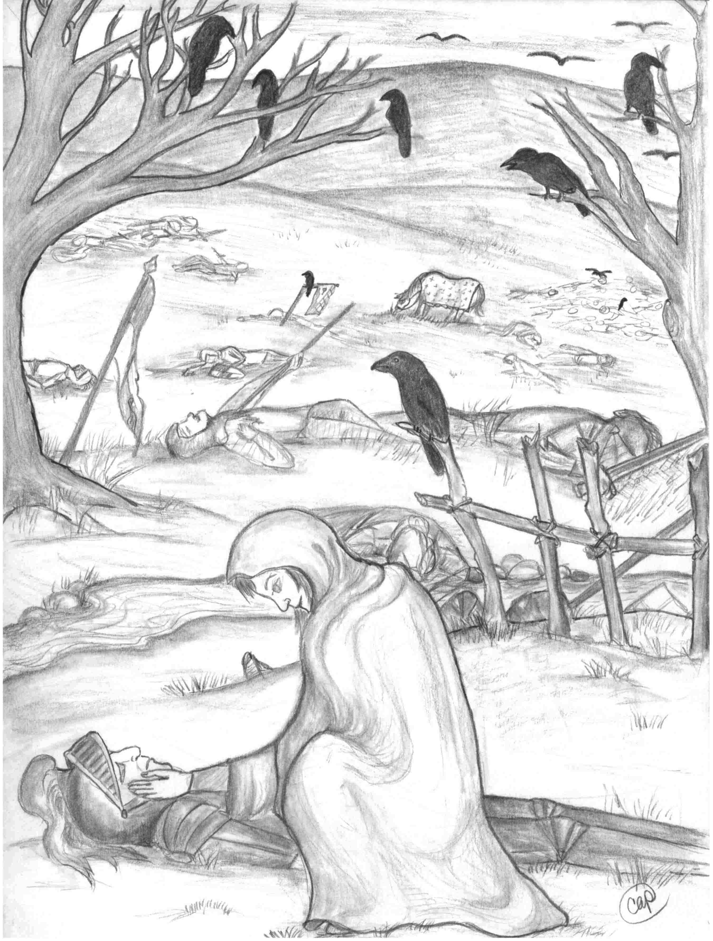

A Time of Turning Over Corpses by Chastity Pureheart @ 2009
And so instead, I turn the dead men up to face the sky,
Crack open armored graves and ask,
“How came you to lie in this place?
I try and name each lifeless face, pour out, perhaps, a dram of grace
From some more generous mental space
While mud fills up my shoes.
No saint, perhaps I hope to lay their haunting spirits down,
Forever to the raven's claim, to offer all that's left to worm and weed And weather's due,
And spare myself the further shock of cold, dead touches
in the gloom,
Of ghost threats in an empty room,
And harm that never quite spells doom.
The raven, following in my wake takes note,
And mocks their fixed stares,
And cackling, plucks a grudging memory free,
Then leaps aloft to fly.
And I wonder, as her black wings clap the sky;
Does she laugh at them the more,
Or me?

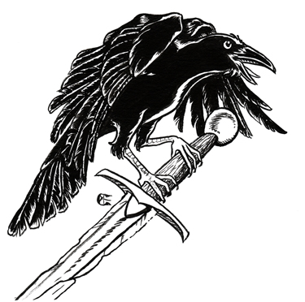

Stigmata Luna

I Bleed.
My flesh brings forth the signs of my faith in monthly devotions.
Un-pierced, un torn my Moon Chamber drips blood, rich and dark and strong.
In sanguine haze, I display the wounds of my Goddess,
A tiny fragment of Her pain. But who am I to claim the agony
Of a million birthings, a million slayings between each dawn and dawn?
Countless heartaches, betrayals, rapes, and ravagements She endures,
And still forgives
And still provides.
I Bleed
And feel the twisting wring of Life within my core.
Though for now the life within me is but my own,
My womb echoes with every birthing breath and cry.
The fire of my blood towers in strength so vast and ancient,
That I must become weak to bear it up, for even a handful of days
My breasts, made holy by Her grace, swell and ache to feed,
As does She, the hungry, and heartsick, and helpless of the world,
Though they number more than stars.
I Bleed.
In aching extract I stretch my arms to hold Her
To comfort my Goddess as best my weak flesh can.
The tears of blood and pain pass through me, renew me.
I am Sacred in this state, and pure, for this is the blood of Innocents
That flows from out my loins, and someone must weep for them.
Who but my Sisters, and our Mighty Mother to see their mourning done?
The Goddess leans upon us all like this, but some few have learned
To love the touch of her strong, red hands.
I Bleed.
And for a week, may say unto the Frowning Sky
"Behold, I am become LIFE, Destroyer of Despair!
All shall know Me, and rejoice!"
For a week, the Moon, my Sisters and I,
We give birth unto the future in bloody benediction.
Through us, by way of Her, all things are possible
I Bleed.
I do not die of it.
That alone is proof.

Tamer

You could tame Lions.
This I know from looking in your eyes -- your gentle hands
Have never liked the feel of whip-leather
And yet,
You could ride Tigers
And I can tell from poise and careful words
That saddle straps and bits and spurs
Are far beneath your skill.
Your skin and scent discourse and force a compromise
Finding diplomacy in danger, sympathy to savegery
With just a look
You could command Dragons
And face their Sturm and Drang unflinching,
Till the tantrum fire and lightning wore away to grudging silence,
A lowered head, and ruby eye opened to your patient reason.
Wolves walk at your heels,
And scent a mystery in your mastery
You, no player in their policies, seem still to take the prize
And when the grizzled Alpha tests your mettle ‘gainst his rank,
The contretemps is meaningless and brief

When you sleep you pillow your head soft
Against the dark-starred flanks of leopards
Who purr their sphynx-like dreams into your eyes,
Which there remain after you wake
No Hercules, you -- No Alexander.
No Lion of Nemedia draped empty on your shoulders,
Denoting stolen force,
Neither wilting laurels of blind men’s blind worship
You stand too tall for either

But Eagles sing your worth to Heaven’s vault,
And Sparrows light and laugh upon your shoulders,
Knowing you can live with me.

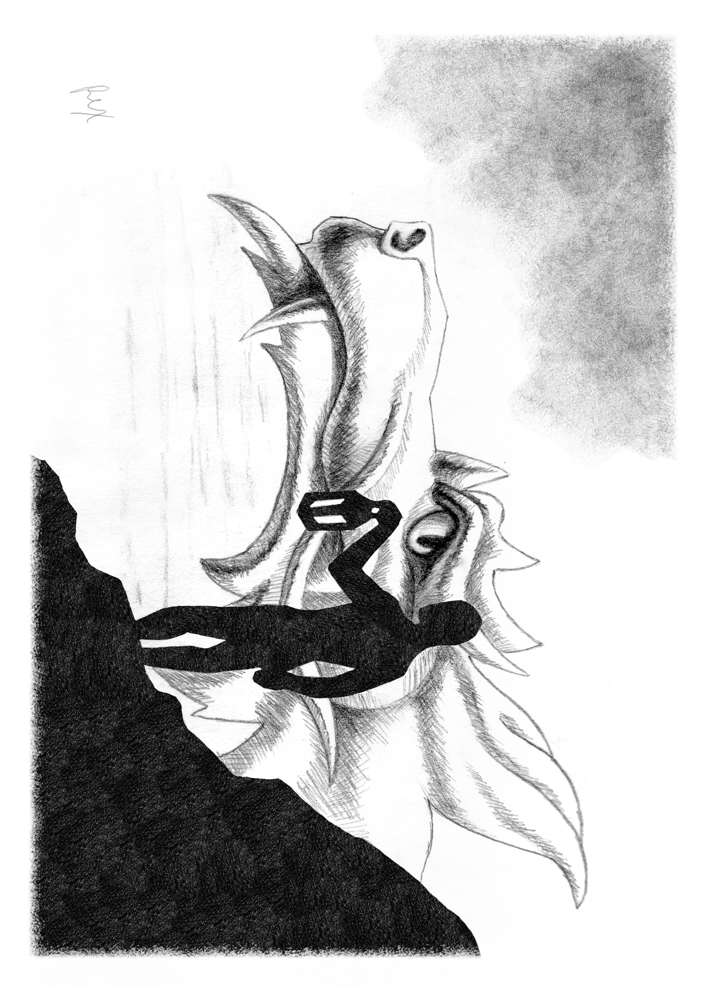

Tamer, by Rexluscus @ 2009
Light

There’s no baby in my stable, no shepherds on my lawn
But a tree of lights gleams in my home,
and my yule log burns till dawn.
I don’t light the menorah, I won’t be at midnight mass
But I know one thing this winter’s eve; that darkness cannot last.

Candles for the King’s birthday, and prayers for Ramadan
Quema del Diablo, and Dong Ji red from the pan
Bon nen kai to lose your woes, Kawanzaa’s seven lights,
They all boil down to say: “You’re not alone this winter’s night.”

I wish you light whenever you need it
And a flame within your soul
To warm your heart in wintertime
When everything feels cold
I wish you love with never the asking,
Given freely from the heart
And measured not in gifts, but in
The glow that eases the dark.

Amid the Christmas carols, And the shopping, and the rush
The reason for the season speaks in every snowfall hush;
That things must have their turning, both the blooming
and the freeze
But to last the night, we all need light, and hope for winter’s ease.

So I hope my flame has kindled something good within your life
I hope this song I’ve written might ease just a bit of strife
But even if my hopes can’t reach beyond the season’s noise,
You’ll still require light to help unwrap all of your toys

So take this light whenever you need it,
At your table, or your tree,
Your candles, or your hearthfires,
I offer it for free.
And it’s all right to let it pass by you
But if you add your own light too,
This circle is made whole
When I take fire back from you.

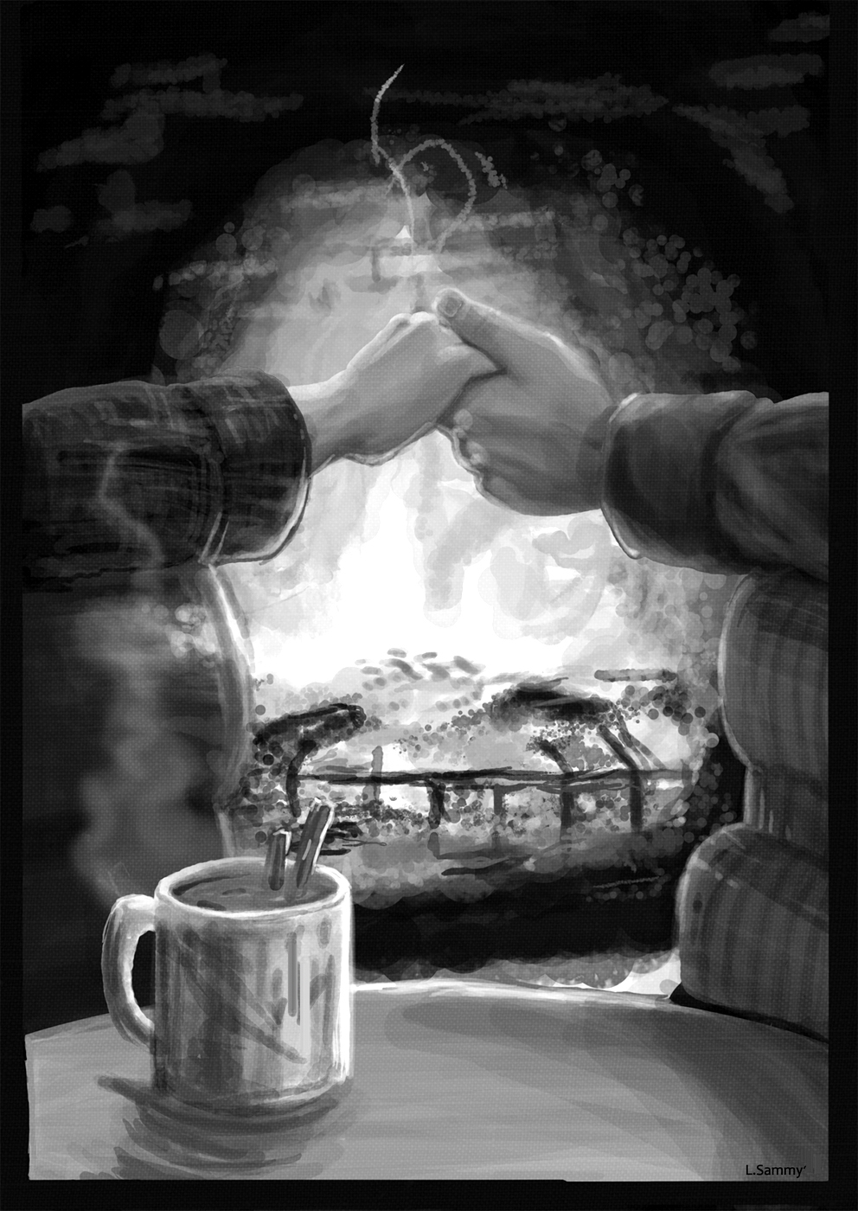

Light by Loraine Sammy @ 2009
Merry and Merry and Bright

There is light in every darkness
In the Christmas, in the Yule,
In the eight nights full of candles
In the winter's eve bejeweled,
When the common folk remember
All the best that life can be,
And the hope that keep us going
Takes the shape of star, or tree,
Or an old man in a crimson suit,
Or groaning feasting board,
Or a small and crowded stable,
Or Forever's gleaming sward,
But the point to all this brightness
On the cusp of winter's eve
Is that WE must light the darkness
With what joy we may conceive.
May the shadowed places in your life give way
To the fire you burn within you on this day.

Catt’s Farewell to Texas

The dying sun glares in our faces
And the wind will be colder tonight
The winding road traces far lonelier places
Rambling away from the light.
We are trading complacency’s comfort
For the challenge in finding new ways
But familiar voices that question our choices
Whisper, and wish us to stay

So we pause for a time, on the summit
And regard, in the westering glow,
All the green and the blue and the shallow and true
Of the lives we had both come to know
And this comfort we offer behind us:
Though absent, we do not forget
And though distance may part, with a sting in the heart,
You have given us little regret

For the things that might be are but shadows
And remembrance is weathering stone
And the lonely may strive to create them a tribe
But inside of our skins we’re alone
Still, the stone of my memory is painted
With angels of shimmering hue
And their eyes, and their smiles, their stories and styles
Look exactly like each one of you.

I will now give the sunset my shoulder
And take the cool twilight in hand
Set my wings in a glide and entrust that the tide
Leave me standing wherever I land.
For life’s not about destinations
And no one can guess Destiny’s hand,
So you laugh, and you cry, until one day you die
And then we might all understand.

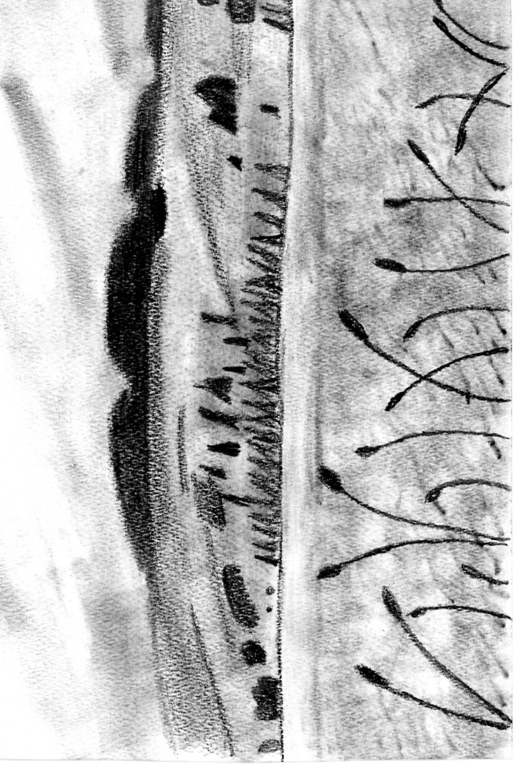

Caledonia by K Simmona @ 2009
Leaving Caledonia

Oh, bonny Scotland, I do not care to go.
I’ll be flying off tomorrow with my heart stuck fast below
I’ve grown drunk upon your people,
I’ve been sobered by your rain
I have breathed your brilliant Autumn,
And I’ll never be the same.

When the rolling mists of Stirling go to rest upon the ground
And time deserts the castle standing high above the town,
My heart will give a shiver, wherever I may stand,
For by this my soul is altered, greater far than I had planned.
When I feel the sting of winter flying wet into my face,
To the waters of Loch Katerine my heart shall speed apace;
To the soaring of those mountains,
To the silence of those glens
And the lilting voices asking; ‘When will ye come back agin?’

When the sun breaks through the heavens
After days of gentle rain
I’ll be thinking of Lake Mentieth, and the Priory again.
I will breathe the ancient grace
That steeped from every stone and tree
And no matter where I’m bound,
For that brief moment, I’ll be free.
From Autumn’s fire, the Trossachs will arise within my mind;
With their Hazel, Ash, and Rowan girded in with somber Pine.
I’ll be dreaming of Loch Lomond
With each flash of brilliant sky,
And although I leave tomorrow, I will never say goodbye.

Oh, bonny Scotland, do not think that I am gone
Though I left October with you, In my heart, I linger on.
The blessing of your sun, and benediction of your rain,
And your people’s lilting laughter swear
I will come back again.

Rants and Rades
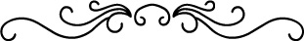
Liberty Dances

Saint Liberty's dancing on the street corner.
No stately minuet, this dance, and no hoochy-cooch either;
It's an unignorable burst of joy from her green foam crown to her
natty Converse souls.
It shakes her like a gospel choir, a convulsion of flashing grin and scarlet, fuzzy gloves Against the springtime chill.

Today she doesn't have her tambourine, but she's no more ignorable
for want of a few
Pieces of hammered tin.
No one fails to see her there, however hard they try;
It is more than her minimum wage job to be noticed,
It is her will, her fire, her hope, and her passion,
And she will not be ignored.
Her red gloves dare you to try.

She catches my eye there at the stoplight,
Looks straight through my windscreen, points me out with a scarlet
finger, and shouts
Her head shaking, as though bedeckes with cowrie shells and gold,
As though crowned with Deity and the Sun on Solstice morning,
And I don't read her grinning lips, or hear her words over the
mumbling radio,
But I know her meaning:

Why are you not dancing, Child?

I pay her with a smile and a promise, which she accepts with Empress grace
And as I drive away, I think she's got the right of it;

Liberty isn't freedom, really; freedom can be chained.
It isn't wealth, it isn't ease and comfort,
It isn't a cozy paycheck and 200 channels of cable.
It isn't a 401k, or a welfare cheque, or the right to vote for someone
who lies for a living,
Or any thing that can be held in hand, or trod under greed's foot,
It's this.
This one, vibrant, joy-filled street corner.

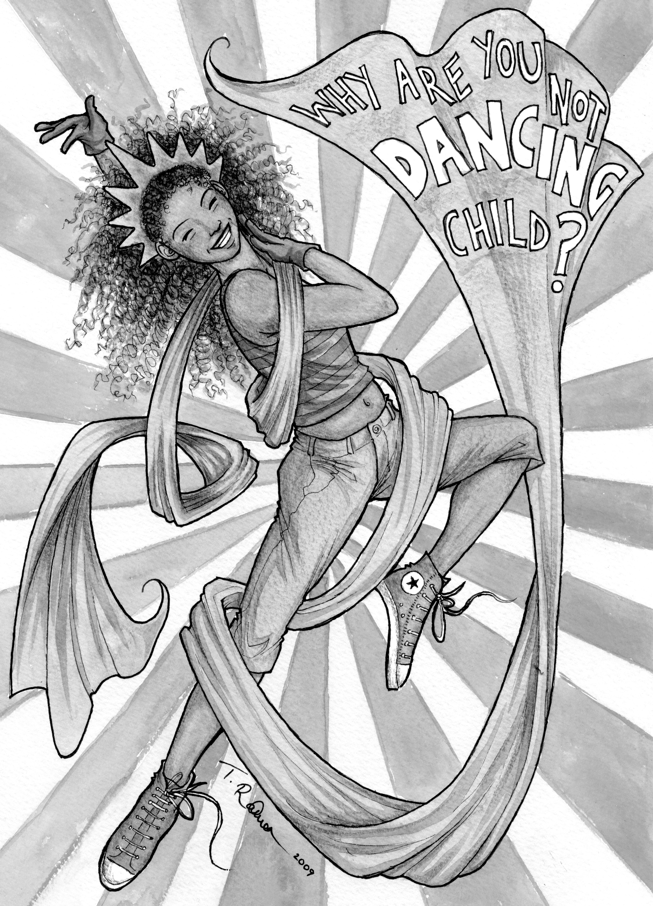

Liberty Dancing by Tanya Rahnan @ 2009

Liberty isn't silenced by war or want or a nasty cold wind,
She isn't patina'd by industry's grime, or pimped out by politicians.
Her eyes aren't hollowed with drug, nor dewy-wide behind rosy glass.
She sees the crumbling tenements around her,
The shopfronts boarded, and workless folks huddling along icy
walks,
While the joyless folks, with the means to just pass through
Just pass through.
And she dances anyhow.

Liberty isn't static, stoic, staring out to sea from some harbour stone;
Liberty is dancing -- dancing when they don't pay enough
for you to stand still.
Dancing when the world around you is too discouraged to sing.
Dancing when things could be better.
Dancing when things could be worse.
Dancing because she cannot, will not be stilled.
Dancing so that she will not be ignored.
Liberty is dancing.
And nobody can stop her.

Amen.
Oh Amen.

Cosmopolitan Sonnet

Thy lime is first; one quarter to each flask
Which, ice be-rimed, are priméd to their task.
Thy vodka from the frozen state decant:
Two ounces, pure, for each participant.
Of Triple-Sec one ounce, then half again
And of Cranberry juice the same refrain
For every every glass your potion's meant to fill
And if thou brew'st it fair, the rosy swill
Shall senses all bewitch; five ounces each,
Into the limed, be-rimed martini's breech.
One citrus zest, wrung hard across each draught,
And rose o'ertakes the mind, howe'er so fraught.
But ask me not whence all this rhyme commences
For I've had two, and so you're lucky I can manage the scansion at all in these bloody sentenceces! thus make no pretences.

Frozen Jerico

You stood outside, upon the level plain
And shouted like a trumpet to my heart
Professed to love, and evidenced the same
And bade me tear the hoarfrost gates apart.

Then, hearing in your cries the ringing knell
That echoed peals of courage long denied,
I leapt from frozen limbo into hell
To warm the ice-torn heart you so decried.

The doors of every stronghold I flung back
To stare like one struck blind into your light
Now find the walls of ice begin to crack
And you, my love, seek but a foe to fight.

Dost now you understand this thing I am?
Thou hast not breached a city, but a dam.

Your Purdah

No.

I will not wear this veil, this caul,
This shroud to hide the marks of pain you left upon my heart.
Yours is the hand that made my face look so
And lo; Yours is the fear that bade me cower low
And lo; Yours is the hate made me afraid to grow
It was your mouth, with razored fang and breath of bitter vitriol
That burned these eyes of mine from simple blue to salty green.
I still weep bloody tears.

No.

I see where you have painted this dank cloth with shame and loathing
It is heavy, dark with mold from graves of countless others
Who have strangled in its folds.
How dare you hold it out to me with poisoned smile, as if to say
“We speak not of such things to strangers, Dear.”
Your voice is fear, and in your eyes I mark the shape of buried fact.
And I will answer

No.

You speak not of such things to strangers,
Nor to yourselves, your children-toys, nor even unto God. And yet,
No Angel stays your hand, your tongue,
Your creeping, seeping lust and shame from reaching out
With sick caress, contagion in your touch you kiss and whisper
“No one needs to know about you.”
But in your eyes the truth is loud —
“Except for you and I, my dear. We two will always know.”
My flesh still crawls in memory, but I have blood enough to answer

No.

For I have grown to like the feel of truth upon my cheeks,
However stinging wet the fall.
And I have grown to trust the gleam of love in other eyes
that mark my triumphs and my tragedies,
My strengths and my sublimities.
They ask me only one great favour — that I Speak;
Eye to Eye, Mind to Mind
(And lo; the brilliant treasure, which you covet,
and destroy within the shadow-catacombs you call a heart)
Soul to Soul.
I will not sell mine into silent slavery to suit your social sham
I will not play your game
I will not bear your shame
Wear it yourselves.
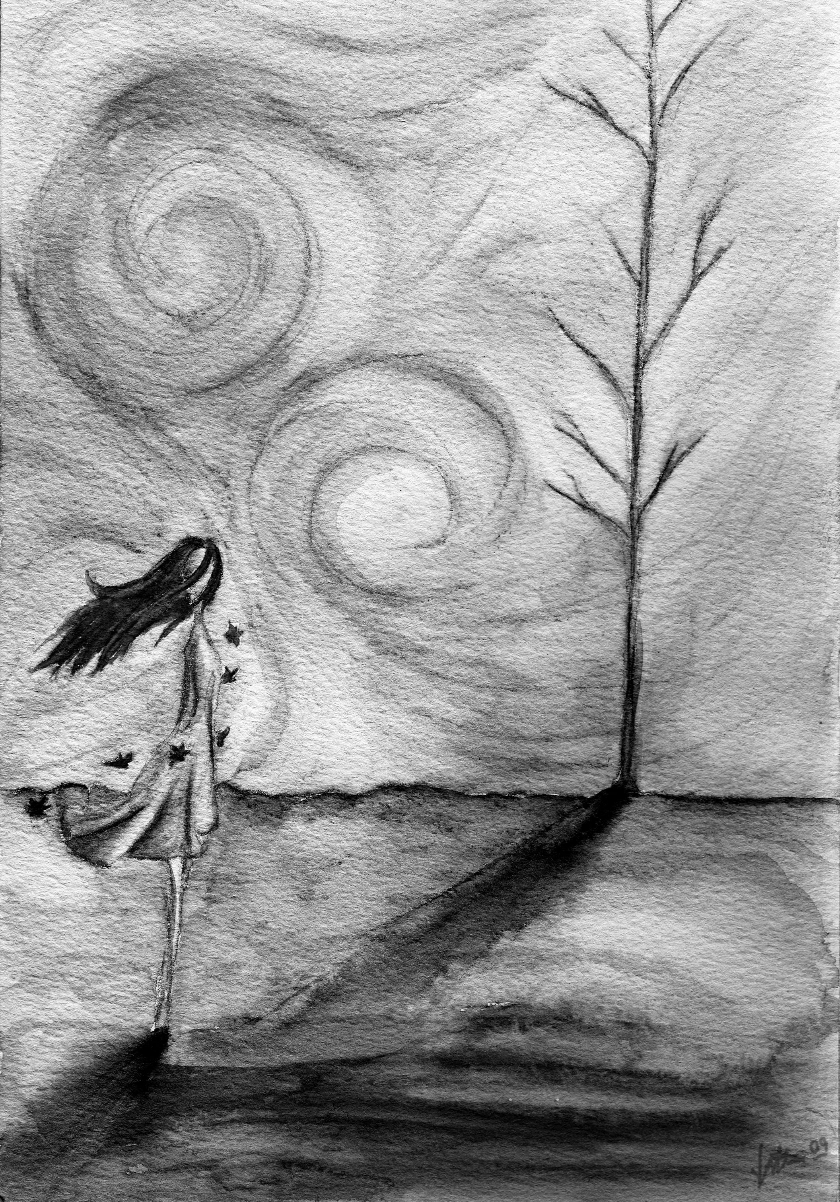

October Country by Nimori @ 2009

October Country

I think that I could live all my life
In any country but October.
Spring, of course, who wouldn’t live forever
There? The first-robin days scented
With flowers on peach twigs, rose on grey.
Yes, I could live forever there. Summer,
Yes. Gold washed air
Heavy and sleepily clover smelling,
Dark green, adolescent leaves,
And the nod of summer flowers droning with the bees. Yes, there too.
Even dead winter, with the air
So heavy with cold, nostrils sneeze,
Where muted earth colours around the snow
Clouds of spoken thought hang in mid-air
‘til after the speaker has forgotten them
even there.
But October, no. Not when the rain converts
Autumn’s fallen glory to sloppy
Sponges that cling to your shoes like leeches.
The trees feel barest in October when the wind
Cries louder than ever, and the lost scraps,
Discarded papers scuttle forlornly before it.
Anywhere, but not October.

Morituri

We who are about to die salute you!
We who have no life but pain fear not the end of living.
You can let your easy life delude you,
But we go forth with death our only aim.
You don’t see the casual devastation that you cause
You can only see what makes you right.
And you don’t own your part in orchestrating our loss
And claim our innocence might have lived if we had chosen not to fight.
But one can swallow just so many ashes,
And one can stomach only so much shame.
And if our vomit stained your sweet illusions,
You must pardon that we don’t accept the blame.

And we who are about to die salute you!
We take the trash you’ve left us with and eat till we are full
And we raise saluting fingers to refute you
For domestication hurts far more than pain
And you can offer us your charity.
And you can preach about us till you’re blue
And you can wallow in your popularity
And everything we say of you will somehow still be true
And you will wonder whenever you see us
In those moments when your notice strays from Ego, Lust, and Greed,
What makes us seem to think that you’ve betrayed us
And how your wild oats blossomed into so much bitter seed

So we who are about to die salute you
You may now resume regretting that we didn’t turn out well
For as of now we’re glad we do not suit you
And we regard with scorn your selfish aims
And we who are about to die salute you
But don’t think that you’ll get to see our blood upon the sand
We simply close our eyes to you, our ears and minds and lives to you,
and leave you only memories to which to raise your hand.
We steal your greatest treasures -- the objects of your scorn,
And we take our selves to silence, and in no way are forlorn
That we sacrifice your notice and the hope of your regard
For the freedom of our dignity is plentiful reward.

And we who are about to live salute you.

Depression

So what do you say when your world turns grey?
When all that you cared about wanders away
From the sound of your voice, from the reach of your hand
And to save your own soul, you cannot understand
Why it all fell apart, when you first lost control
When the cracks in your heart spread across to your soul
And your mind, and your hands, and the soles of your feet.
What do you do when the loss seems complete?

And no one, it seems, understands that your sorrow
Is more than just petulance, laziness, greed
They smile and they shrug when you fear for tomorrow
It isn’t their fault they don’t have what you need
They suppose you will find your way out of the darkness
And call, if you climb within reach of their hand,
And a part of you knows you can’t label them heartless
They care, but that doesn’t mean they understand.

So you cope, you cope, you learn to hope
You try to fly with a twist of rope
And a wad of gum, and a wing and a prayer
Cause you know if you fall, no net will be there
You don’t get the comfort of indecision
Despair is a luxury you can’t afford
So you take a deep breath and you act with precision
To come out ahead, when the tallies are scored

And you never forget that the dark overcame you,
When you and eternity stood eye to eye,
But the shadows blinked first, and the daylight reclaimed you
And promised you strength with a glimpse of the sky
And a breath of the air, and the rain on your face
And a knowledge that never so dark was the place
That your grief led you in, and despair bid you stay,
But the fact of your living can’t unbar the way.

Best Vengeance

I never knew, when you ruled earth and sky
How small and scared you were inside
Your shadow loomed o'er all my dreams
Till I longed for death to hear my screams
In the night -- which was all that you left me
From the fright -- That you were all that I could be,
When the taste of desperation burned like bile against my tongue,
When disgust at growing up outweighed the fear of being young,
Ten years later on, in retrospect I wonder what there was to cry about.
I have outgrown you. And I got out.
I wonder what it was made you afraid
To love the life that you had made
What demon made it seem the thing to do
To crush my spirit under you,
Was it envy -- Made you teach me I should fear
That I was crazy -- That the gloom would never clear

I used to plead for some vague rescue, from a God I hardly knew
Hoping sometimes that He'd kill me, other times that He'd kill you,
Funny that it was a Goddess gave me what I really needed all along
I have outgrown you. And I am strong.
I look back now and find you frightened, in the bed that you have made
And a piece of me is satisfied at Karma so displayed.
That mind which you so valued, now your greatest enemy
The pollution of your lifetime now is obvious to see.
Of the hate that raged within me I can barely find a spark
When I think about the loathing that lives with you in the dark
It is pity now that fills me when I see your petty crimes
And wonder that I didn't see through you a million times
Back then...

I don't bemoan my life, but I don't credit you
With much that I have learned how to be proud of.
I've learned a lot from strife, I won't deny it's true
But far more I value being clear of
Your vicious circle -- And the war you cannot win
If I don't fight you -- Then your wheels can only spin
Once your scorn ran so much deeper than the greatest of my hope
Your disappointment stripped away all my capacity to cope
I have come to know myself and I have come to understand
That you lost the war the minute that you chose to raise your hand
And I will walk away in triumph to a life that you could never understand.
And know that in the end: I have outgrown you.

Firebird’s Aria

I know when I am wanted, however far removed
And though you know it not yourself, I know when I am loved
I feel the tug of longing, although you never knew
When netting down a thieving bird, t’was I entangled you.
I know.
I know when I am wanted.

I feel you stroke the feather that I left within your grip
I hear the name I taught you tremble, unsaid on your lip.
I know you dream about me, though your eyes trace other sights;
Of magic, wealth, and power, and a maiden frail and white.
So fair.
I know when I am wanted.

You saw my eyes of amber and you dreamed her golden hair
You watched me soar and thought of eyes like to that brilliant air.
Her dancing grace, her lily brow, all this you loved from me
I don’t begrudge your mortal love, but wonder if you see
The truth;
I know when I am wanted.

The wizard dead, his servants fled, my debt repaid in full.
And I could fly without the weight of unpaid honour’s pull
You had your pretty princess there, clinging to your sleeve,
But I saw you stretch your hand when I arose to take my leave

I know when I am wanted, your longing never dies
And when your lady’s sleeping, I can hear your passion’d sighs
I know if I should ask it, you would offer me your life.
I know when I am wanted, but I wonder; does your wife?
Poor thing.
I know when I am wanted.

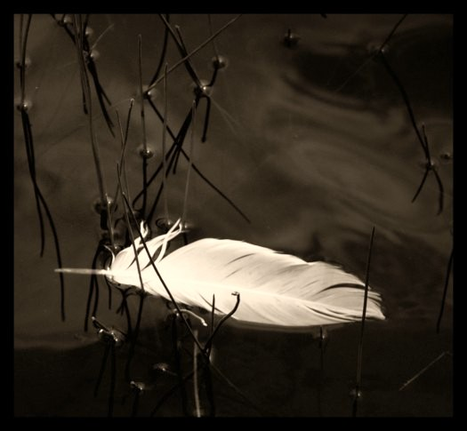

Feather by Neevel @ 2003
Paradise Crossroads Blues

Oh Daddy, what have I done?
I let myself be led from the path you set me on,
And now it’s overgrown, I can’t find my way home
And all I ever thought I knew is gone
Oh Daddy, I’ve gone and done it now.
I made no one a promise, I took no sacred vow
I’m still your little girl, but now I’ve seen the world,
And I know where the blame is coming down.

But oh, it tasted good. Oh, Daddy, just like you knew it would.
I feel its bitter sweetness burning in my brain
And yes, it’s gonna cost; I know what I have lost
But I have no regrets about the gain.

Come a day I know I’m gonna regret it
Gonna come a time when these eyes of mine are blinded by the tears,
But I’ve seen too much to ever forget it,
And the secrets you thought you only knew are ringing in my ears.
Oh Daddy, your little girl’s changed. I’m never gonna be the same.
I know you can be gentle, and I hope you can be kind.
But nothing can erase the changes in my face.
I guess I’m not the girl you had in mind.

Daddy, you had to know. You pointed; you know you showed me where to go. (And how to get there)
You know I’m not the strong one; you drove her far away
But I know too much now to cower or to bow
And you and I got nothing more to say.

And I don’t suppose you’ll ever forgive it.
You made us all, set us up to fall, but we still bear the blame
And your every daughter’s gonna relive it;
The pretty face, the fall from grace, and a lifetime of fighting off Shame.
But oh, Daddy; just one more thing. This little song,
you know it wants a harmony.
I won’t go like my sister; the shadows aren’t for me.
I might be a disgrace, but I won’t be replaced;
Your little boy’ll be growing up with me.
Your little boy, he’s all grown up with me.

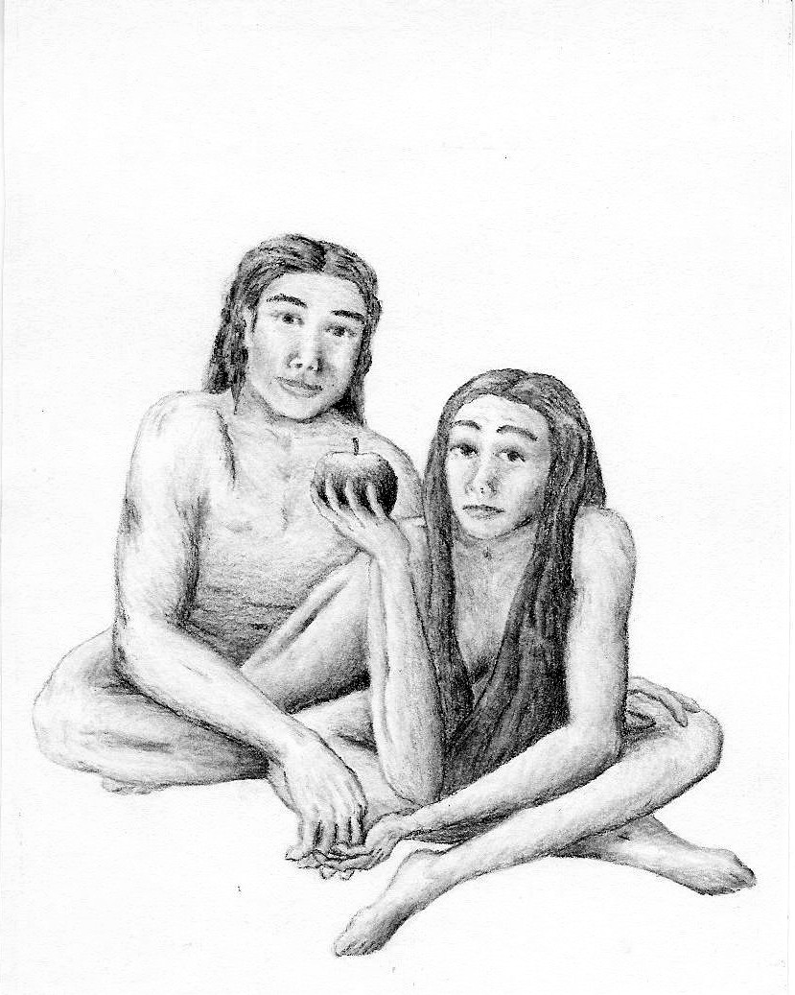

Eve by LeAnn Wood @ 2009
The Crucible

Take first, a pound of cold, unloving lead;
Pain-scarred, and trusting not the warmth of care,
Graven with names of the Repented Dead,
So rife with pain, of pain now unaware.
Add this, upon a chill, wind-addled night,
To Hallow’s leaves hag-riding ‘cross the sky,
A rag of cloud to blind the full moon’s sight,
And the transcendent logic of your sigh;

‘Neath architecture of your perfect throat,
White marble, dewed as with the sea’s regard,
The blazing flame that trails your finger-stroke,
Can shatter that base metal into shards.
Then captured, every fragment, in your breath
So like a ghost against the evening shade,
The cant of your wild voice bespells my death,
As in your fire, I find myself unmade

And you, Green Lion; precious, fabled prize
By mage and man through lingering ages sought,
Wild alchemy at work within your eyes,
Your lips brim-full of life-elixir’s draught
The fountain of your youth, a leaping flame
The touch of which consumes this common dross,
One taste, one kiss, and nevermore the same
O, death and madness both are worth the cost.

And now held fast within your athanor
My sulfur, salt, and mercury alloyed,
Denatured, these base properties, and more,
By Grace refined, all detritus destroyed.
One final gasp, a whispered scream, I die,
Unmaged, unmanned, shattered, and formed anew;
Transfix’d upon your fearful symmetry
Transmuted in the crucible of You.

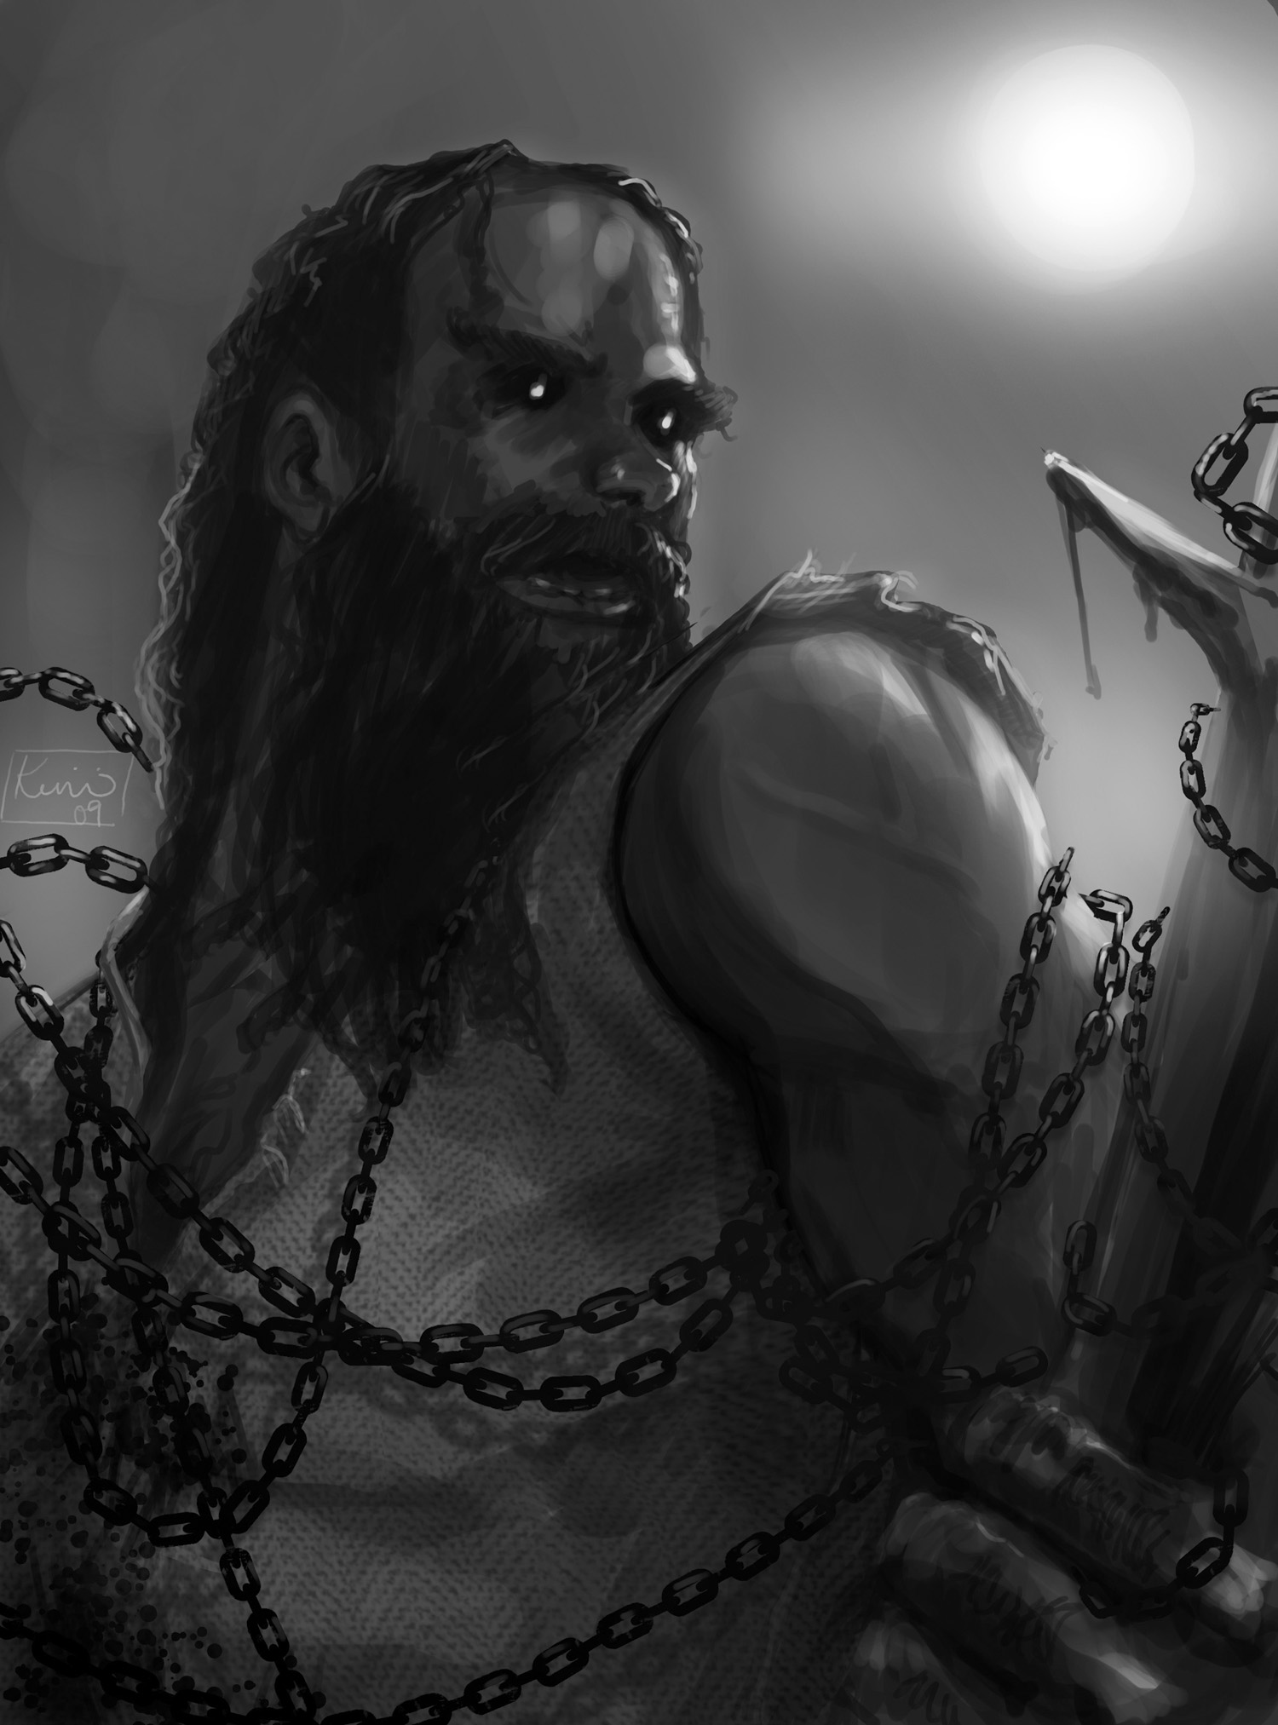

Jack in Irons by Kimi Owens @ 2009
Jack In Irons

On the moorland tracks of Scotland
In the moon’s uncertain light
It is often that the mists will cloak
The world in faceless white
Then a man could walk beside you
But you’d never see his face
And a mob might march behind you,
Full fog-muffled in their pace.

On such a wicked night
The moor-folk have a tale to tell;
Don’t go out upon the moorlands
If your life you value well
For apart from mortal dangers,
Worse than any man could be
Is the giant Jack in Irons,
Whom no man has lived to see.

And it’s clank, clank, clank
There’s a heavy step upon the road
Clank, clank, clank,
Any wonder that your blood runs cold?
And now come down your choices;
Do you take the chance to flee
Or meet the giant jester
Of the court Unseeligh Sidhe?

Not a man knows where he comes from,
Not a man knows where he goes
But he always leaves behind
A battered corpse in bloody clothes
And sometimes the head’s been crushed
And other times it’s fully gone.
No one laughs to find the giant’s jokes
Beside the road at dawn.

But it’s sometimes that a traveler
Will laugh at such a tale.
With a smile to all grim warnings
He will take the darkened trail
Then, perhaps an hour later
When the moon is in the sky,
The hounds will raise a clamour
As if death is looming nigh.

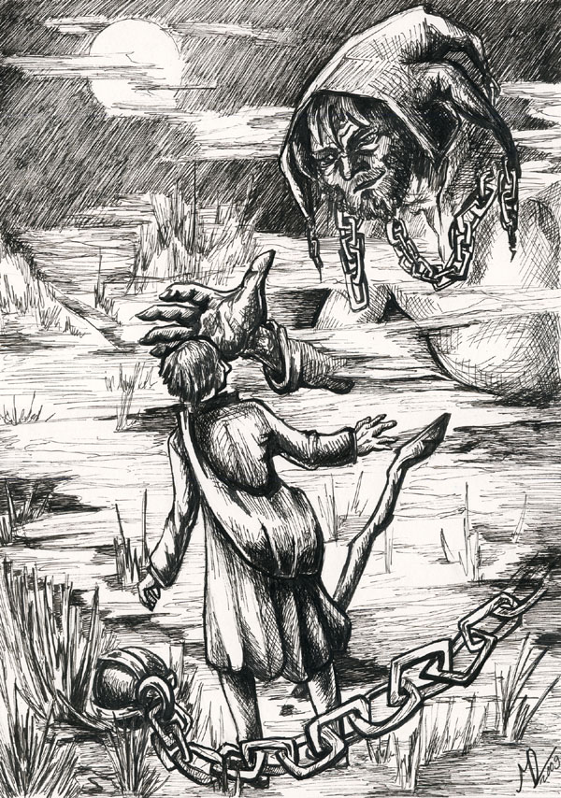

Jack the Jester by Marina Degtjarova @ 2009

And it’s clank, clank, clank
There’s a heavy step upon the road
Clank, clank, clank,
Any wonder that your blood runs cold?
And now come down your choices;
Do you take the chance to flee
Or meet the giant jester
Of the court Unseeligh Sidhe?

Oh the local folk will shiver
They will turn a little white
And each one will thank the Lord
It isn’t HIM out in the night
And when dawn reveals the slaughter
Of the fool they tried to warn
There’ll be not a one surprised
He didn’t live to see the morn.

On you cannot blame the moor-folk
If their words you didn’t heed
And it matters not to Jack
If you abhor his bloody deed.
You can only blame your folly
Should you find you’re not alone
When the moorland mist is rising
And you’re far away from home.

Then it’s clank, clank, clank,
There he stands before you in the road
Clank, clank, clank,
Very proper that your blood runs cold
You’ve run out of choices
For there’s no time left to flee
The deadly Jack in Irons is come
To make his fun of thee.

The Measure of Dust and a Shadow

How do I measure you, rag and bone girl?
How do I figure your weight in this world?
In volumes displaced? In litres of waste?
In output, or throughput, or level of taste?
Your dress size and shoe size and hat size don't tally
When force becomes form exponentially,
But scansion and metre can't frame up the lot
When line, hue, and balance don't fit in the pot
With the things you know true,
and the things you've been through.
How could what you are not be more than you do?
Can your measure be taken in negative space?
In the good or the harm, in the curse or embrace
That gives lift to the struggling, or hope to the lost,
Or stands with the fearful to raise the sum cost
Of attacking?
Are you just momentum effect,
And a wing-flap that midwifes a hurricane get
Of another mind's brilliance, another soul's dreams
While you struggle to burst mediocrity's seams?
Or if worth may be known by one's friends and one's foes,
Your having of neither -- not such that it shows, --
Gives too scanty a sum to contain the equation;
Your heart and your hands and the healing abrasions
That testify effort, and caring and strain
To bear up what you can, and from hatred refrain.

You're not adding up. You're epitrite fractions,
And candyfloss lightning with endless redactions,
And I cannot tell if your world-weight is less than
Or equal, or more than the cost of your elan,
Your ennui, your ardor, your hopes, and your dinner;
You'd not matter more, whether richer, or thinner.

No eye, and no hand, whether mortal or im
Can frame what is fearful or fine in your trim,
In the mad, asymmetrical force that is you,
And if you weren't here, there's no way to guess true
If the world's been made better, if you were worthwhile
If the journey was worth every long, lonely mile.

Or if, like the sand on eternity's shore,
You're a self-obsessed blip like a billion before,
And a billion to come.
No different, no better;
A life, nothing more, with no mystical fetter
Of fate's validation to set you apart
As you live, and you die, and wink out in the dark.
I don't know your value. It cannot be guessed;
Let the words on your grave lay that riddle to rest.

Get A Life

Just let me start this out to say I’m sorry that I laughed
When you said the world was like a fortress city
and you stand outside the wall
and shout and pound and plead and call
For it to open up and take you out of pity.

And it may seem out of place, but I just can’t keep a straight face
When you go on about how no one understands you
Cause you’re so alien and strange,
and you’re so broken and deranged
And that means you don’t have to cope with what life hands you

Well, you may want sympathy, but don’t look for it from me,
Cause baby, I can hear the bull behind the bluster
So the world’s dealt you some slaps,
grab your own fucking bootstraps
Because it’s laziness that drops you off the muster.

Cause baby, I know;

There’s been a million born,
knew hurt the way that you know

There’s been a billion torn
And bled from scars that you show.

And every one was just as human, just as lost inside as you
And every one got all their breaks, and every one got all their clues
And when all the bitching’s over, and the breastbeating is done,
It doesn’t matter how you suffered, if you lost, or if you won.

What matters is that you got just the same as everybody ever born:
You got a life
You parade in your mistique, looking all tragical and chic
Dancing all the steps that smell a bit like danger
Your black baloon, your extacy,
And all the sex you think you need
And when you sober up, you still feel like a stranger

Now I don’t want you to think that
I don’t understand your pain
Baby, I’ve lived things I wouldn’t wish upon my dearest foe
All I’m saying here to you
Is that your pain is no excuse
And the world has every right to expect you to grow!

So when your pity party’s done,
You find your angst is not so fun
And you get bored with being wretched-er than thou
When you’re finished getting off
On being oh so all alone,
Drop the curtain on your fashion play and take yourself a bow

Then get a life
That’s all that you were promised.

Just a life;
There ain’t no quality control.

You get a life.
And you choose it or you lose it
You embrace it, or you waste it, either way, it’s up to you.

You get a life — and you ride it, or you fight it,
You can love it, you can loathe it, you can treasure every bruise.

You get a life — cause that’s all that you got coming
It may suck beyond the telling, but whatever you may choose
It’s all the same in the end, cause I promise you, my friend,
you’ll get a life

